Evidence for Project Unit

Joe Stafford

E21

P.5 User Sitemap

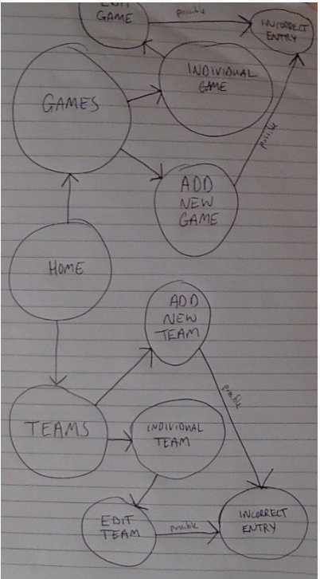

P.6. Wireframes

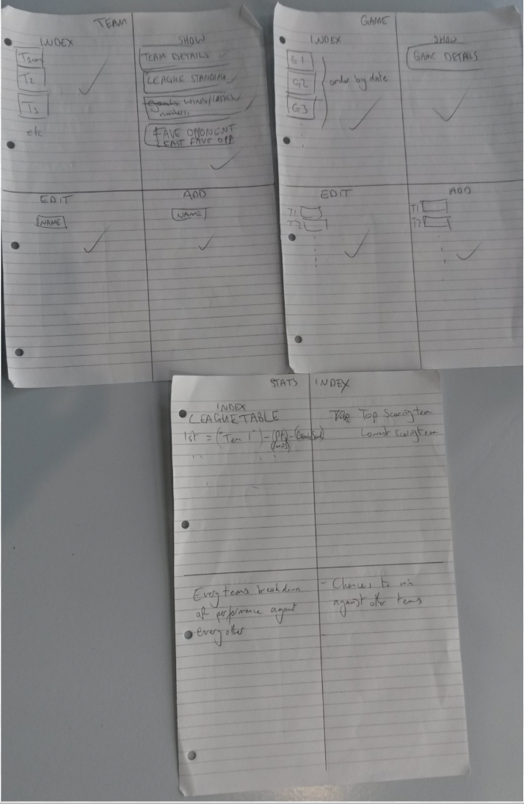

P.10 Pseudocode

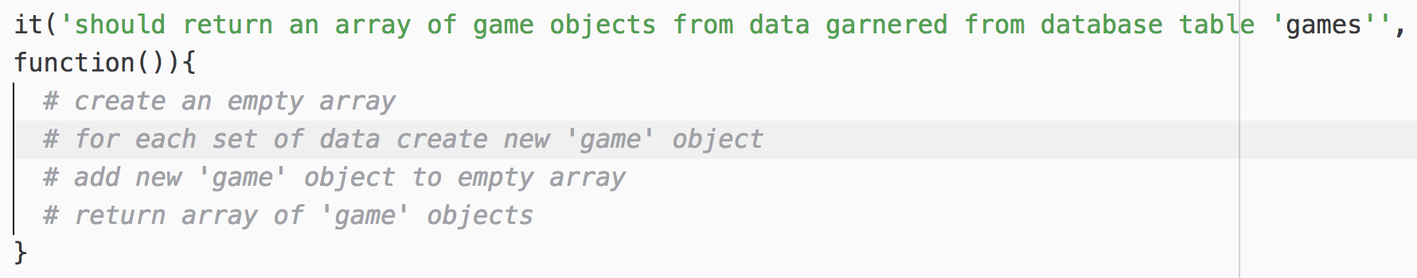

P.13 User​ ​input​ ​being​ ​processed​ ​according​ ​to​ ​design​ ​requirements

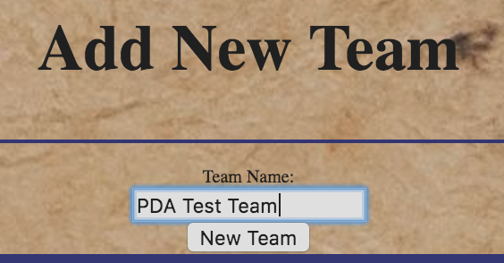

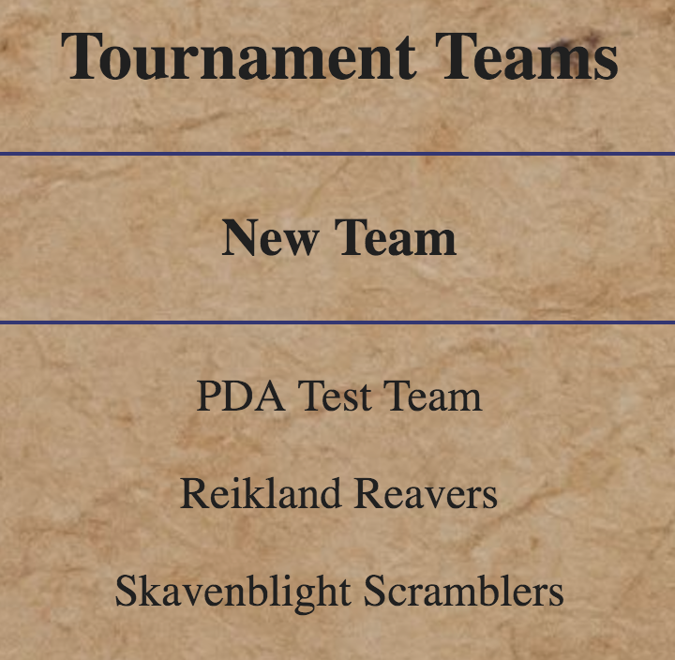

P.14 Show​ ​an​ ​interaction​ ​with​ ​data​ ​persistence

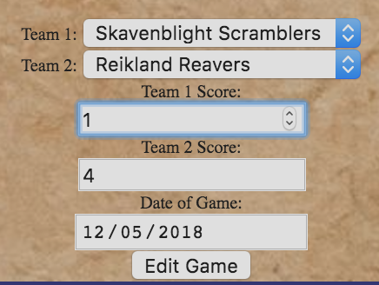

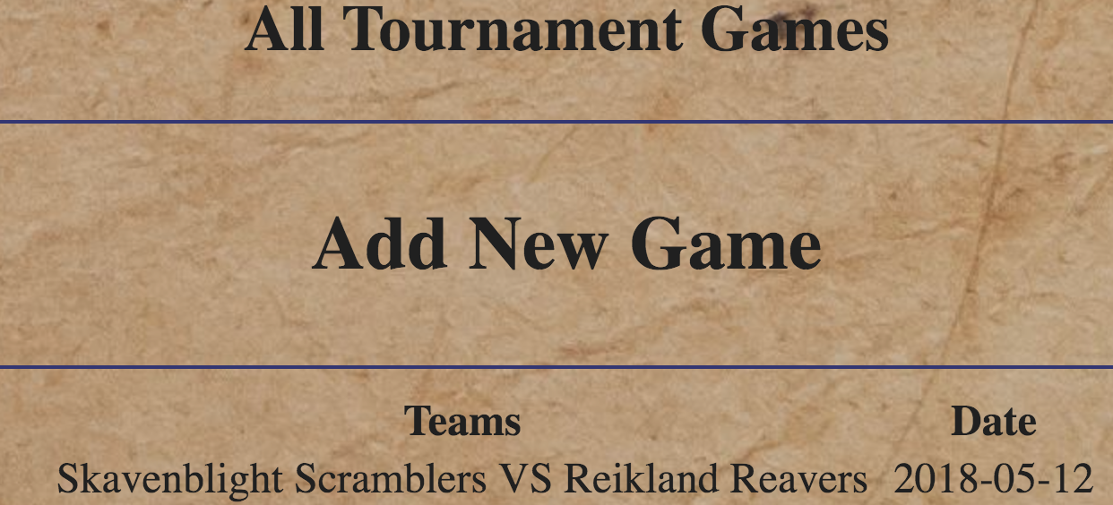

P.15

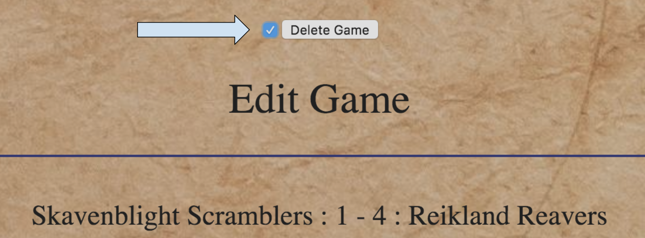



P.11 - Screenshot of project (file structure)

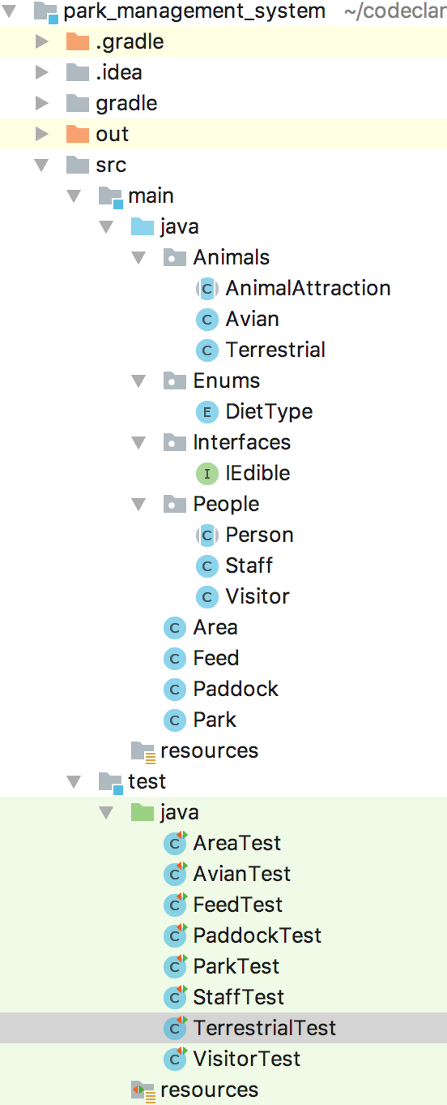

* Link to github repo - <https://github.com/JoeStafford1986/java_park_management_system>

P.12 - Take​ ​screenshots​ ​or​ ​photos​ ​of​ ​your​ ​planning​ ​and​ ​the​ ​different​ ​stages​ ​of​ ​development​ ​to​ ​show​ ​changes

* Kanban

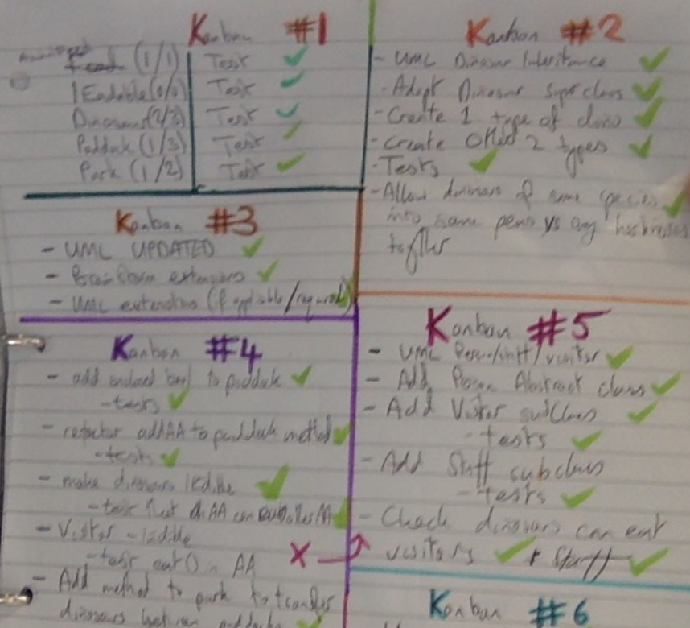

* UML diagrams evolve over time
  + 1

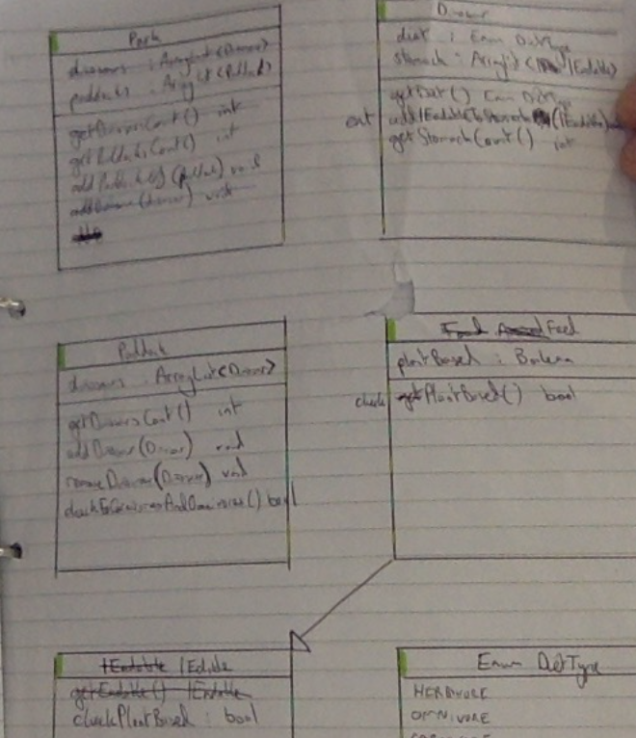

* 2

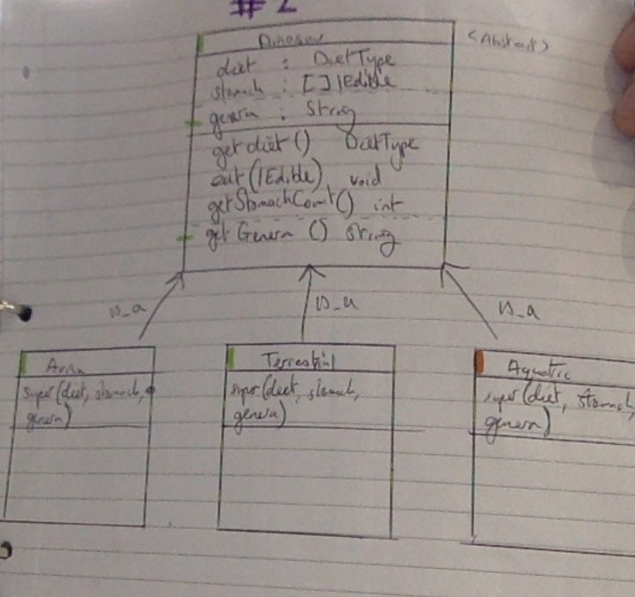

* 3

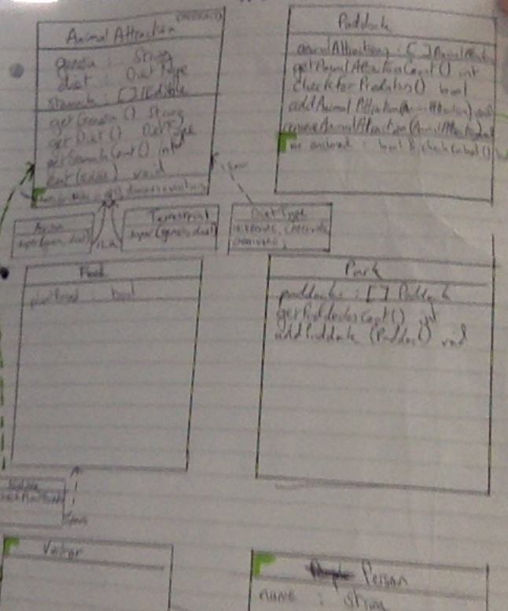

* 4

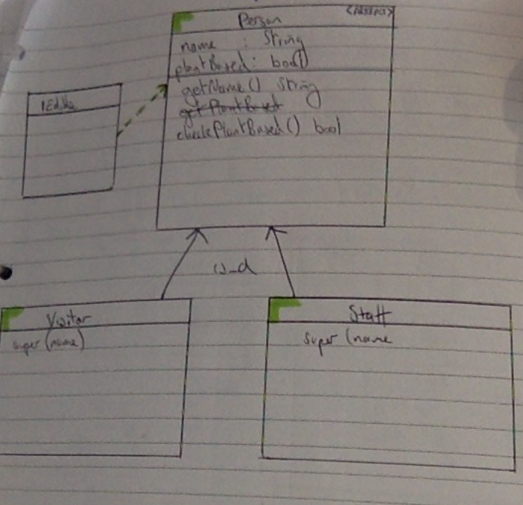

* 5

